**Aim: Program to simulate FTP using TCP protocol.**

**Code:**

**Ftpserver.java** package ftp; import java.io.*;

import java.net.ServerSocket; import java.net.Socket; public class ftpserver {

public static void main(String[] args) throws IOException { ServerSocket serverSocket = new ServerSocket(4002); System.out.println("Server started. Waiting for client..."); Socket socket = serverSocket.accept();

System.out.println("Client connected.");

// Open input stream to read file FileInputStream fileInputStream = new

FileInputStream("/home/shivesh/Desktop/shiv/rt");//Please change the link as per you PC BufferedInputStream bufferedInputStream = new BufferedInputStream(fileInputStream);

// Open output stream to send file

OutputStream outputStream = socket.getOutputStream();

BufferedOutputStream bufferedOutputStream = new BufferedOutputStream(outputStream); byte[] buffer = new byte[8192]; // 8KB buffer, adjust as needed

int bytesRead;

while ((bytesRead = bufferedInputStream.read(buffer)) != -1) { bufferedOutputStream.write(buffer, 0, bytesRead);

}

System.out.println("File sent successfully.");

// Close resources bufferedInputStream.close(); bufferedOutputStream.close(); socket.close(); serverSocket.close();

}

}

**FTPclient.java** package ftp; import java.io.*;

import java.net.Socket; public class ftpclient {

public static void main(String[] args) throws IOException { Socket socket = new Socket("localhost", 4002); System.out.println("Connected to server.");

// Open input stream to receive file

InputStream inputStream = socket.getInputStream(); BufferedInputStream bufferedInputStream = new

BufferedInputStream(inputStream);

// Open output stream to write file FileOutputStream fileOutputStream = new

FileOutputStream("/home/shivesh/Desktop/shiv/ct.txt");//Please change the link as per you PC BufferedOutputStream bufferedOutputStream = new

BufferedOutputStream(fileOutputStream);

byte[] buffer = new byte[8192]; // 8KB buffer, adjust as needed

int bytesRead;

while ((bytesRead = bufferedInputStream.read(buffer)) != -1) { bufferedOutputStream.write(buffer, 0, bytesRead);

}

}

**output:**

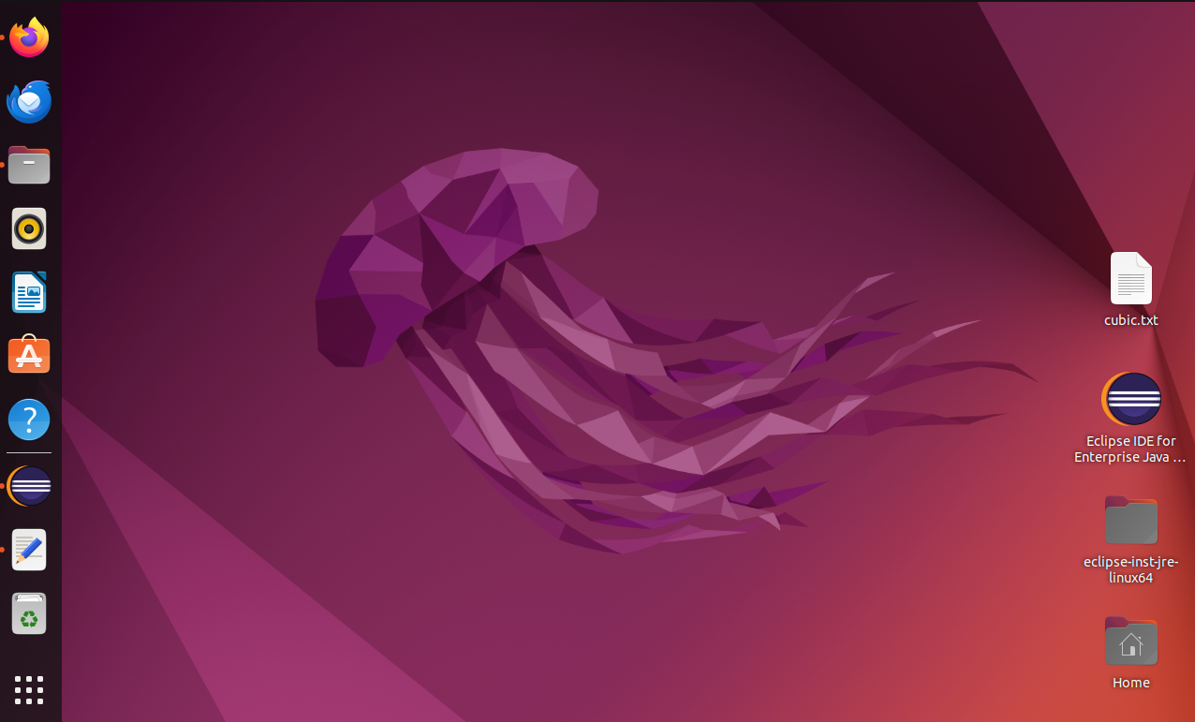

Creating TEXT.txt and giving the value and then put it in server

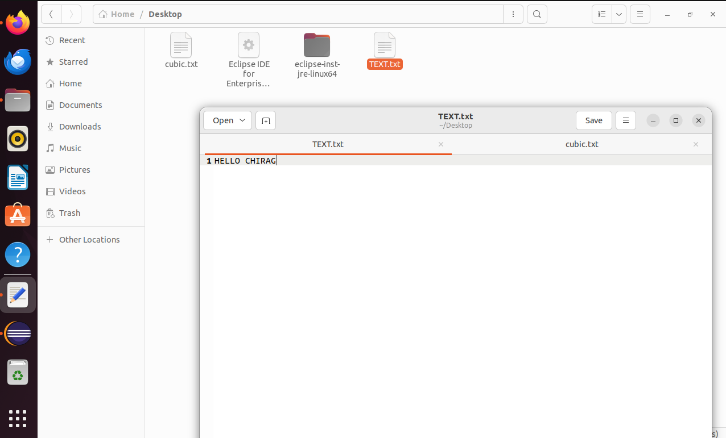

After running the server and client code

